# CS 340 README Template

## About the Project/Project Title

Global Rain was asked to create this application by Grazioso Salvare who works with a great non-profit in Austin, Texas that operates five animal shelters in the area. Austin Animal Center (AAC) looks for dogs that can be trained for things such as search and rescue missions. Our application assists them utilizing Python and MongoDB to create and read from a database. We specifically chose MongoDB for several reasons such as scalability. We feel this would be best suited for AAC’s needs over a SQL database.

## Motivation

We support AAC and the work that they are doing and have worked with Grazioso Salvare and many projects, so it was easy to say yes to this one. We really wanted to create an application that would be easy for the team at AAC to use and would provide them with a quick and quality database. We have implemented CRUD operations in our codebase to try to keep the database well maintained. MongoDB also makes it easy to make things secure by allowing quick and easy authentication setup, which we have implemented.

## Getting Started

While we can’t share the database that the team at AAC uses, we did make our source code free for all to utilize.The codebase can be great for others who may want to run a similar project and could benefit other non-profit organizations out there. This project was specifically designed with MongoDB in mind so you will want to ensure that you download that here: <https://www.mongodb.com/download-center/community/releases>

Python is also used so it is highly recommended that you use an IDE that supports Python 3. While this was coded in Jupyter Notebook you can use others such as PyCharm without issue.

## Installation

Tools used are:

Python 3: <https://www.python.org/download/releases/3.0/>

Jupyter Notebook: <https://jupyter.org/install>

MongoDB: <https://www.mongodb.com/download-center/community/releases>

## Usage

### Code Example

Authentication:

Code snippet for our authentication and read/write functionality:

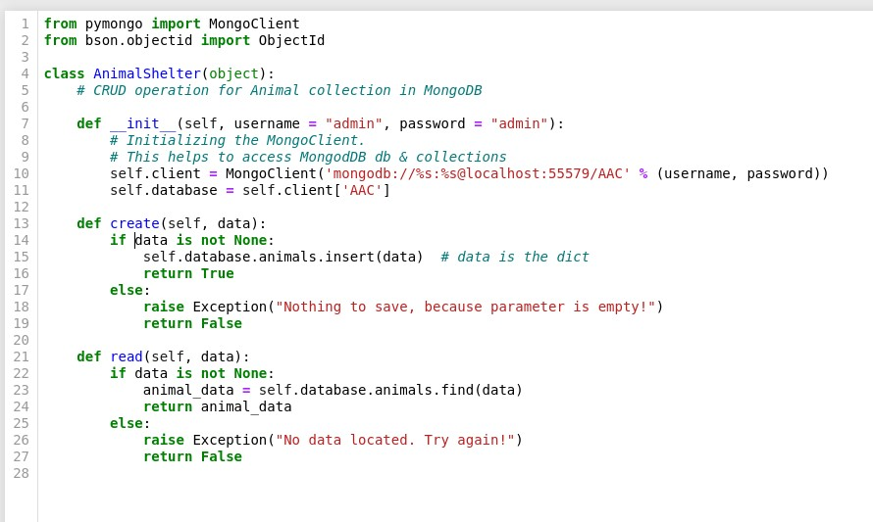

Updated snippet with Update/Delete functions added to complete our CRUD operation

### Tests

Our code is tested along the way. This test shows how you can create one or several entries and test for them to be written out. For this test, they were written in JSON format. A dashboard is planned for the future with a much friendly layout for the data.

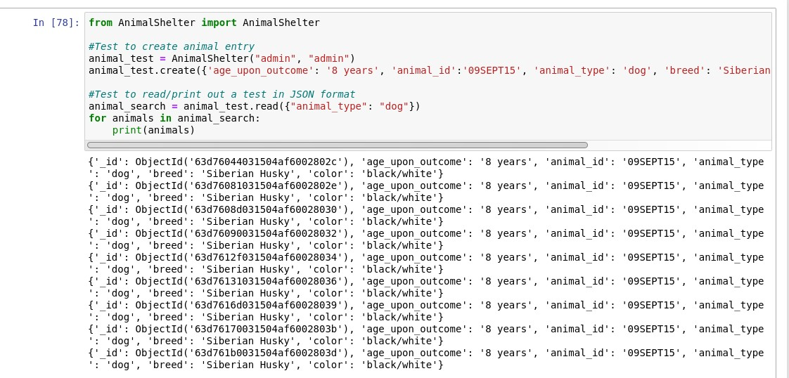

Updating an entry

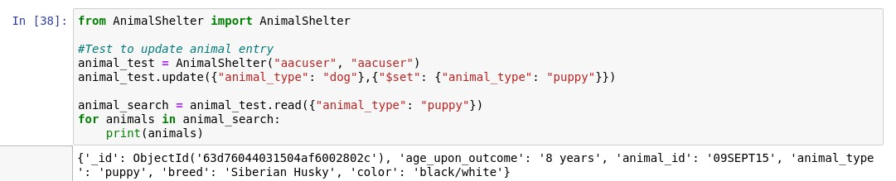

Deleting the entry

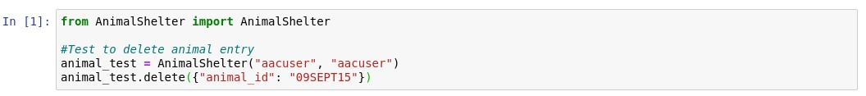

### Screenshots

## Contact

Your name: Ron Causey